SPECIAL NOTICE

On Tuesday, April 9, 2013, the Office of Mineral Resources on behalf of the State Mineral and Energy Board advertised in the “The Notice of Publication” for receipt of sealed bids on or before noon on Tuesday, May 7, 2013 for State Leases to be awarded upon Tract Nos. 43192 through 43226, inclusive, at its May 8, 2013 Lease Sale. Within the said advertisement was an incorrect description. By Virtue of this public notice, Tract No. 43223, Iberville Parish was incorrectly advertised and is hereby corrected as follows:

TRACT 43223 - Iberville Parish, Louisiana
An undivided interest in and to a certain Tract of land, excluding the beds and bottoms of all navigable waters, belonging to and not presently under mineral lease from Louisiana Department Of Public Safety And Corrections on May 8, 2013, being more fully described as follows: Beginning at a point having Coordinates of X = 2,056,600.00 and Y = 555,400.00; thence South 87 degrees 03 minutes 52 seconds East 1,751.90 feet to a point on the Northern boundary of State Agency Lease No. 20712 having Coordinates of X = 2,058,349.60 and Y = 555,310.28; thence along the boundary of said State Agency Lease No. 20712 the following courses: Southwesterly along an arc to the left having a radius of 6,550.93 feet to a point having Coordinates of X = 2,057,910.33 and Y = 555,032.77; Southeasterly along an arc to the left having a radius of 3,513.95 feet to a point having Coordinates of X = 2,059,574.64 and Y = 553,711.91; Southeasterly along an arc to the right having a radius of 4,914.79 feet to a point having Coordinates of X = 2,060,201.94 and Y = 553,467.00, and Southeasterly along an arc to the right having a radius of 5,562.07 feet to a point having Coordinates of X = 2,060,799.92 and Y = 553,000.61; thence South 80 degrees 30 minutes 32 seconds West 1,216.57 feet to a point having Coordinates of X = 2,059,600.00 and Y = 552,800.00; thence West 800.00 feet to a point having Coordinates of X = 2,058,800.00 and Y = 552,800.00; thence North 50 degrees 42 minutes 38 seconds West 2,842.53 feet to a point having Coordinates of X = 2,056,600.00 and Y = 554,600.00; thence North 800.00 feet to the point of beginning, containing approximately 103 gross acres and 51.5 net acres, all as more particularly outlined on a plat on file in the Office of Mineral Resources, Department of Natural Resources. The description is based on information provided by the State Agency regarding location and ownership of surface and mineral rights. All bearings, distances and coordinates, if applicable, are based on Louisiana Coordinate System of 1927, (North or South Zone).

NOTE: The above description of the Tract nominated for lease has been provided and corrected, where required, exclusively by the nomination party. Any mineral lease selected from this Tract and awarded by the Louisiana State Mineral and Energy Board shall be without warranty of any kind, either express, implied, or statutory, including, but not limited to, the implied warranties of merchantability and fitness for a particular purpose. Should the mineral lease awarded by the Louisiana State Mineral and Energy Board be subsequently modified, cancelled or abrogated due to the existence of conflicting leases, operating agreements, private claims or other future obligations or conditions which may affect all or any portion of the leased Tract, it shall not relieve the Lessee of the obligation to pay any bonus due thereon to the Louisiana State Mineral and Energy Board, nor shall the Louisiana State Mineral and Energy Board be obligated to refund any consideration paid by the Lessor prior to such modification, cancellation, or abrogation, including, but not limited to, bonuses, rentals and royalties.

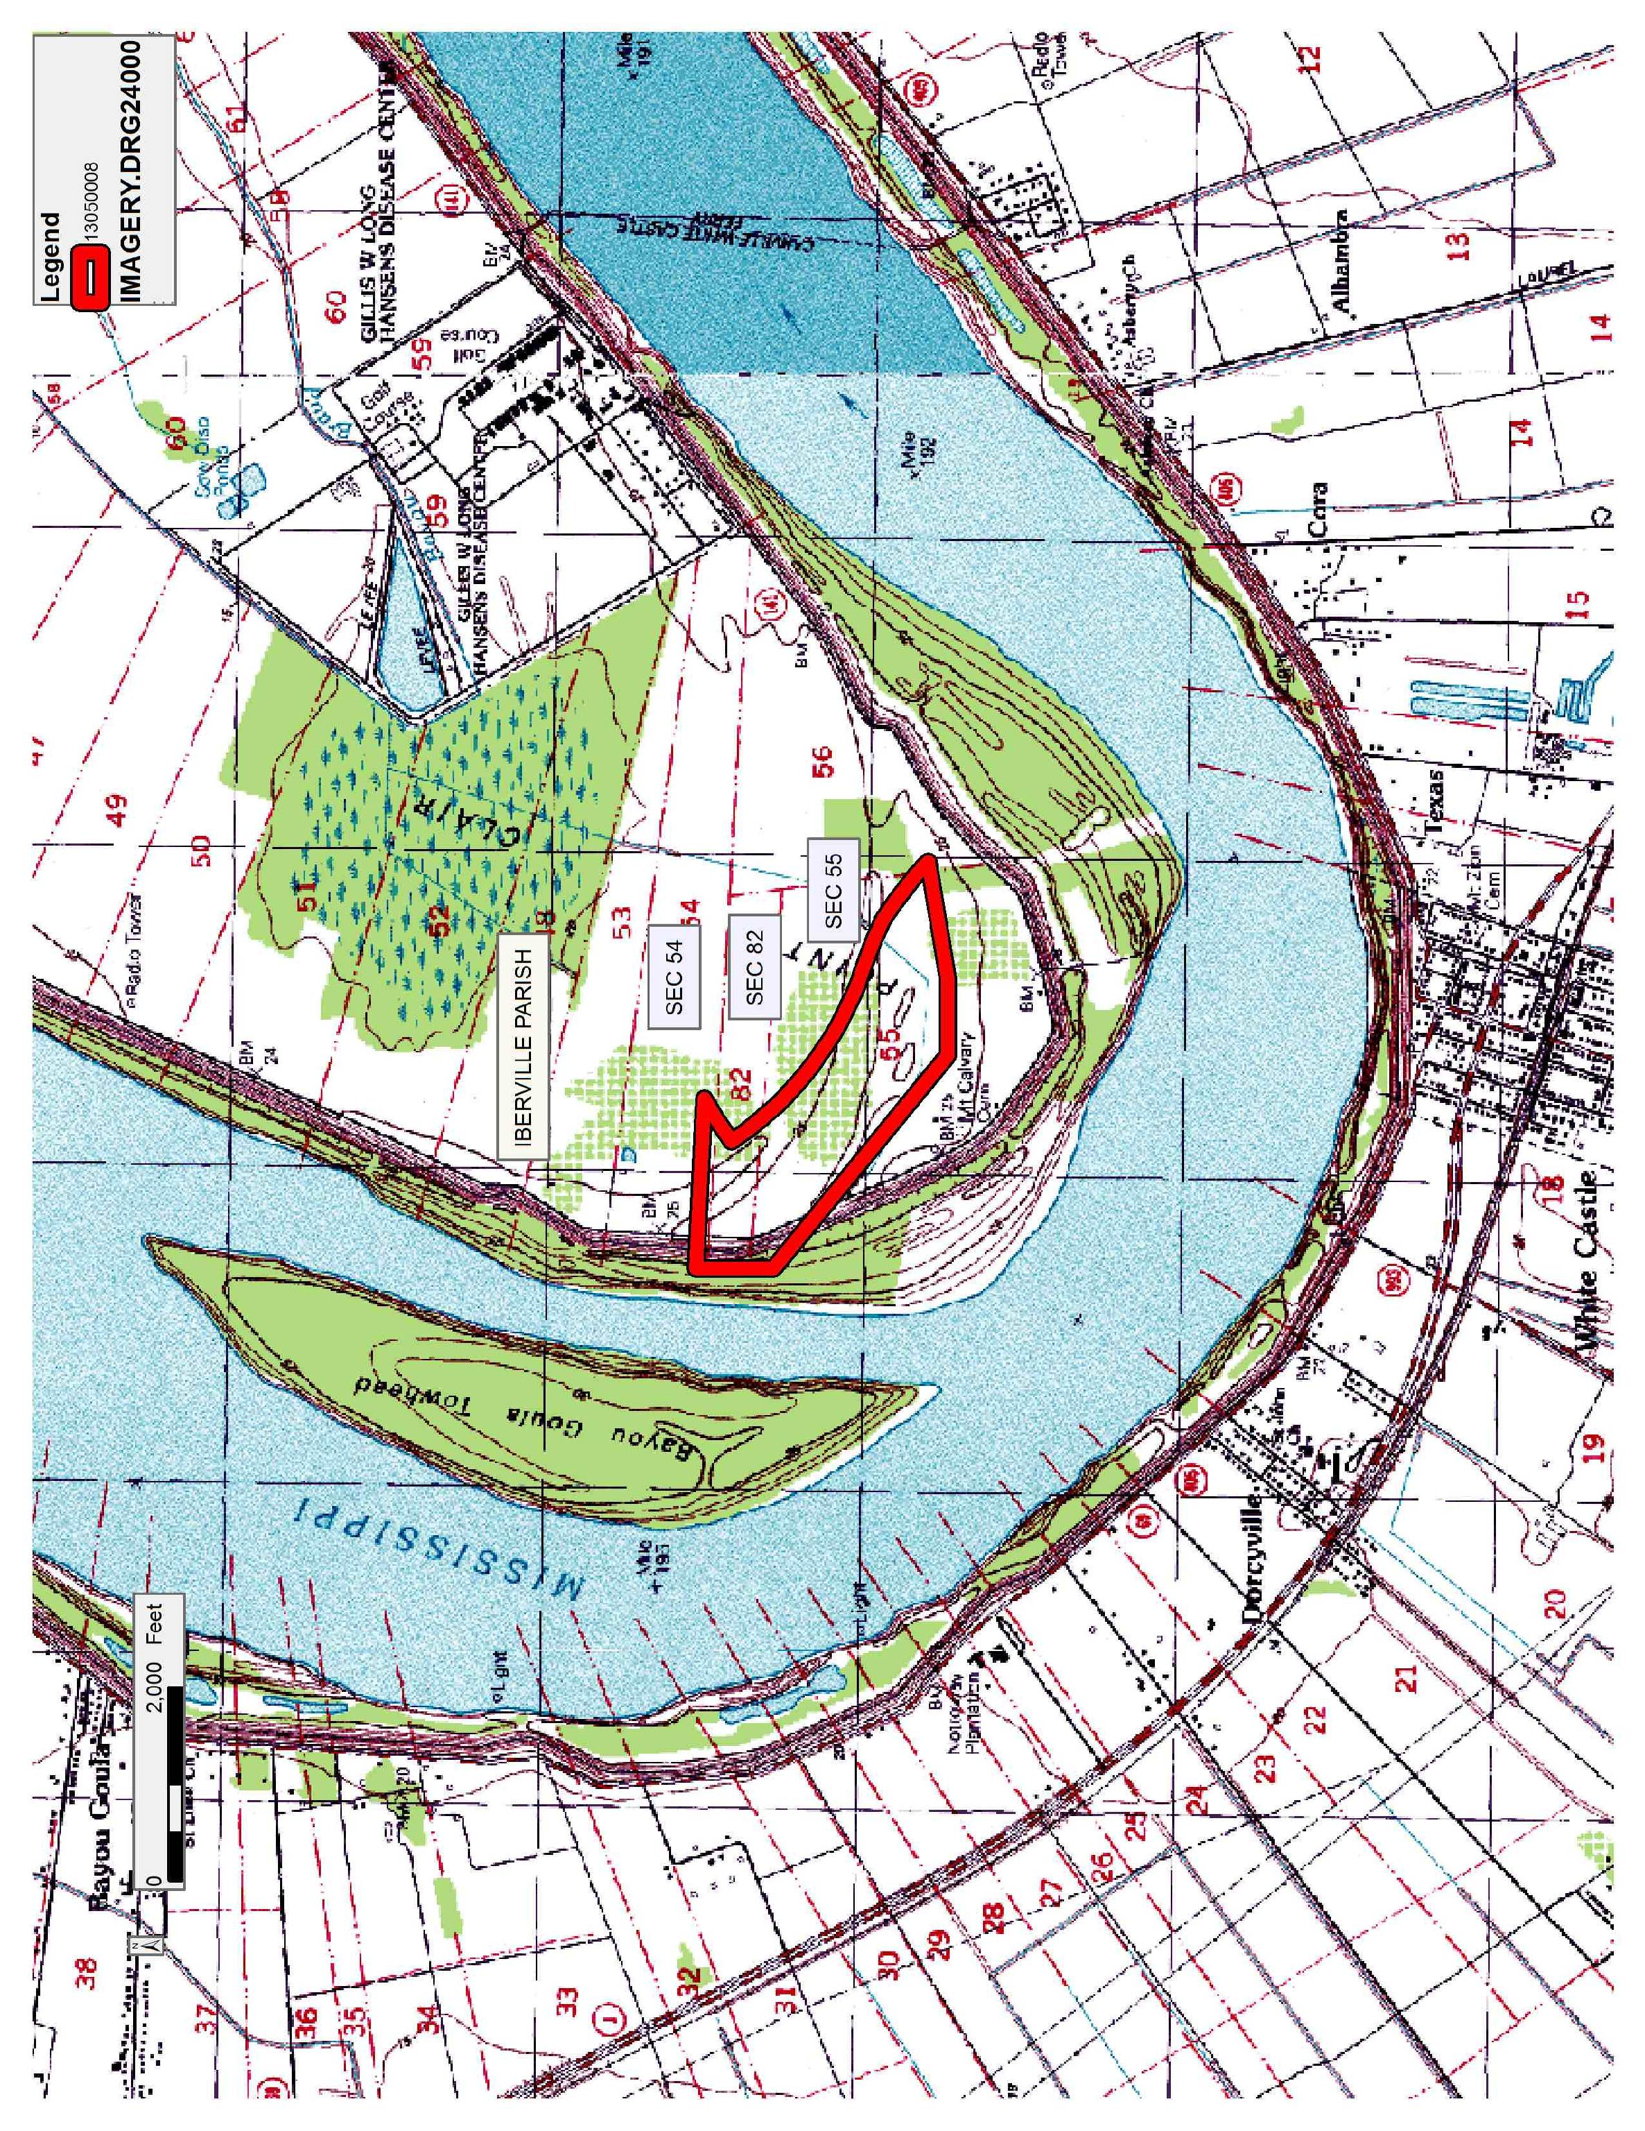

Office of Mineral Resources, Acres: 51.5 Tract Number: 43223

